**Form 1.6. Business process architecture (Process mapping)**

Process mapping can be used to assess the current end-to-end flow of activities and stakeholders, and generate an “as-is” map of the way death registration currently happens in a given setting.

**Step 1: Preparation**

1. **Review available documentation:** Compile available information on the processes and information flow in mortality surveillance system (i.e., their processes and goals). [You can use *Form 1.1.2. Mortality information systems*]
   * Complete the desk review to map out the current mortality data systems and identify key stakeholders, data flows, and processes.
   * Use consultations with key stakeholders to gather input on stakeholders’ roles, data needs, and challenges in the current system.
2. **Develop a draft Business Process Map (BPM)**:
   * Use findings from the desk review and consultations to create a preliminary draft of the BPM.
   * Represent the key stakeholders, processes, data flows, and system components using Business Process Model and Notation (BPMN).

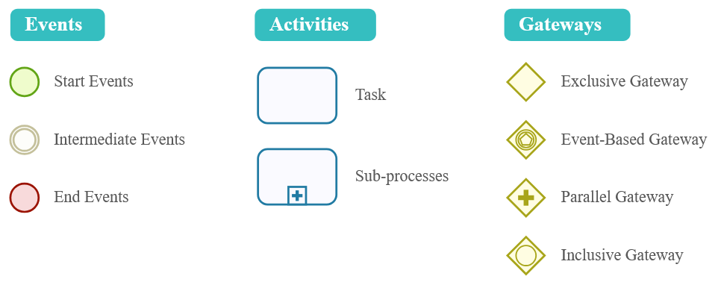

Figure 2. Business Process Modeling Notation (BPMN 2.0). [www.bizagi.com](http://www.bizagi.com)

Table 3. Examples of software applications for Process mapping

|  |  |
| --- | --- |
| **Name** | **Features** |
| Bizagi | Free, user-friendly |
| Bonita | Free, user-friendly, suitable for Mac users |
| Enterprise Architect | Paid software, advanced modeling tools |
| Microsoft Visio | Paid software, focused on process mapping |

1. **Invite stakeholders**:
   * Invite relevant stakeholders, ensuring representation from all critical groups (refer to interest vs power grid)
   * Provide stakeholders with the draft BPM and workshop agenda to encourage active participation and preparation.
2. **Set objectives**: Clearly define the objectives of the workshop:
   * Validate and refine the draft BPM.
   * Identify gaps and align on stakeholders’ data needs.
   * Assess system strengths, weaknesses, and opportunities for SRS integration.

**Step 2: Day 1 – Reviewing the draft BPM**

1. **Introduction and context Setting**:
   * Present an overview of the current mortality surveillance system and the purpose of implementing SRS.
   * Explain the BPM as a tool to visualize stakeholders, processes, and data flows.
2. **Review the draft BPM**:
   * Walk stakeholders through the draft BPM, highlighting key components (stakeholders, data flow, governance processes, etc.).
   * Facilitate discussions to validate the accuracy of the map:
     + Are all key stakeholders included?
     + Does the BPM reflect the actual data flow and processes?
3. **Refine the BPM**:
   * Collect feedback on missing elements, inaccuracies, or misrepresentations.
   * Update the BPM in real-time during the workshop, involving stakeholders in the revision process.

**Step 3: Day 2 – Identifying Gaps and Needs**

1. **Facilitate *Gap Analysis***:
   * Discuss stakeholders’ current data needs vs. what is available in the existing system:
     + What data is missing or insufficient?
     + Are there gaps in coverage, accessibility, or quality?
   * Explore system weaknesses, such as bottlenecks, duplication of efforts, or lack of coordination.
2. **Assess Strengths and Opportunities**:
   * Identify strengths in the current system that can be leveraged (e.g., existing digital tools, governance structures).
   * Highlight opportunities for integration and synergy between existing systems with focus on SRS implementation.

**Step 4: Day 3 – Co-Creating solutions and strategies for improvement**

1. **Explore SRS Integration**:
   * Facilitate discussions on how SRS can address identified gaps and improve the current system.
   * Use the BPM to illustrate where and how SRS components can fit into the existing data flow and processes.
2. **Co-design Improvement Strategies**: Brainstorm and prioritize strategies to improve the mortality surveillance system.